Plan and methods

As it was already mentioned before, the nowadays touch screens are made by using ITO (indium-tin oxide). However, it is predictable that this material will run out within 15 years, that will cause the rise of the price of the material and so we need to find an alternative. It was already proposed the usage of Silver nanowires (AgNWs) and it was proved that this could be a good alternative to ITO. However, there are some problems that appear when using AgNWs that are related to the electron transport between each one of the nanowires, so this means that an impedance greater than the one that is desired. This could be solved by using a greater density of AgNws, but then the solution wouldn’t become viable, economically speaking. The impedance can be minimized by combining the nanowires with other nanostructures.

What we propose is to combine the AgNWs with graphene, due to its mechanical and electrical properties. So, with this proposal we want to develop a sustainable alternative to ITO, improve the touch screen’s impedance and transmission, reduce the cost of fabrication of this type of screens and also enlarge the utilization spectra of the touch screen, since that the ITO is a brittle material so it is only used on flat surfaces. Given the properties of graphene we believe that will be possible to enlarge the utilization spectra of touch screens also to curve surfaces.

To make this objective possible we divided our work on three main tasks:

-Theoretical study and structure modulation (main task 1)

-Manufacture (main task 2)

-Characterization (main task 3)

In the first main task we seek to develop a theoretical model to describe our structure so that we can then compare the results that we will actually obtain, after the characterization, with our theoretical model. The task leader will be António Balula.

In the second main task we will proceed to the structure manufacture using spray coating to deposit the AgNWs (since this method allows the control of a variety of parameters such as pressure and temperature) and we will use the INESC-MN’s machine of graphene deposition to create the hybrid AgNWs/graphene. The task leader will be Luís Macedo.

Spray coating is a technique that uses an arc that is formed between two electrodes in a plasma forming gas. The plasma is heated by the arc and so it will expand and is accelerated through a nozzle.

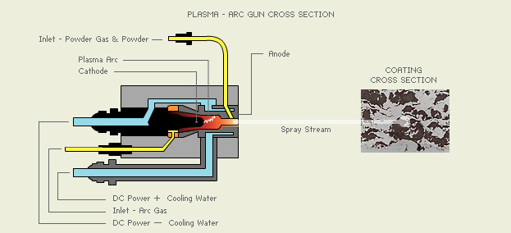

In the third main task we will then characterize our structure in terms of electrical, optical and structural properties. Also we collect this data we will compare it to the theoretical model concerning main task 1. The task leader will be Pedro Ribeiro.

When we talk about characterization there are a lot of measurements that are needed. In this work we will measure the following quantities:

-Electrical quantities

-Impedance and reactance of the material

-Response in frequency

-Determination of the electrical limits for which the material has de wanted behavior

-Optical Quantities

-Transmission coefficient for visible light

-Study of the electrical response of the material varying the wavelength of incident light

-Structure of the material

-Measurement of the optical and electrical response by applying torsion on the structure

-Structural integrity of the material

-Data analysis

-Fit of the experimental results with the theoretical model

To measure the structural integrity of the material we will use the AFM (Atomic Force Microscopy). This method consists on using a probe on a cantilever and then it scans all the structure, so that we can obtain the properties that we desire from our structure.

This project has an ambitious goal but our goal is also a need since it is predictable that we will run out of ITO within 15 years, so we are confident that our AgNWs/graphene hybrid will be a reliable option to this material. Also, if our expected results are confirmed it will have an impact not only scientifically but also economically, since the touch screens will be less expensive to produce.

The partner involved in this project is INESC-MN that has a strong background on deposition and characterization of structures so it is a very good partner to this project, not only because of the knowledge but also because of the infrastructures. The principal investigator of this project will be Susana Freitas witch has extended experience on the fabrication and optimization of structural devices.